Experiment 5

Calculation of Group Velocity, Phase Velocity and Phase Constant of EM Waves in Rectangular Waveguides
Test Case 1
A rectangular waveguide has dimensions a = 4.0 cm, b = 2.0 cm and operating frequency f = 8 GHz. (1) Calculate the cutoff frequency for the TE10 mode. (2) Predict the phase and group velocities for the TE10 mode. (3) If the width is reduced to a = 3.0 cm, determine the effect on cutoff frequency and propagation characteristics.
Code -
clc; clear; close;
V=3*10^8;
a=0.04; b=0.02; f=8*10^9;
m=1; n=0;
fc=(V/2)*sqrt((m/a)^2+(n/b)^2);
disp(fc*10^-9,'Cutoff frequency (GHz) =');
vp=V/sqrt(1-(fc/f)^2);
disp(vp*10^-6,'Phase velocity (Mm/sec) =');
vg=V*V/vp;
disp(vg*10^-6,'Group velocity (Mm/sec) =');
Output:
Original dimensions: a = 4.0 cm, b = 2.0 cm, f = 8 GHz, mode TE10
Parameter | Simulation Result | Theoretical Result
Cutoff frequency fc (GHz) | 3.750 | 3.750
Phase velocity vp (Mm/s) | 339.62 | 339.62
Group velocity vg (Mm/s) | 265.00 | 265.00

Reduced width: a = 3.0 cm, b = 2.0 cm, f = 8 GHz, mode TE10
Parameter | Simulation Result | Theoretical Result
Cutoff frequency fc (GHz) | 5.000 | 5.000
Phase velocity vp (Mm/s) | 384.31 | 384.31
Group velocity vg (Mm/s) | 234.19 | 234.19

Table: Variation of Phase and Group Velocity with a (b = 2.0 cm, f = 8 GHz)
Width a (cm) | fc (GHz) - Sim | vp (Mm/s) - Sim | vg (Mm/s) - Sim | fc (GHz) - Theory | vp (Mm/s) - Theory | vg (Mm/s) - Theory
4.0 | 3.750 | 339.62 | 265.00 | 3.750 | 339.62 | 265.00
3.5 | 4.286 | 355.28 | 253.32 | 4.286 | 355.28 | 253.32
3.0 | 5.000 | 384.31 | 234.19 | 5.000 | 384.31 | 234.19
2.5 | 6.000 | 453.56 | 198.43 | 6.000 | 453.56 | 198.43
2.0 | 7.500 | 862.11 | 104.40 | 7.500 | 862.11 | 104.40
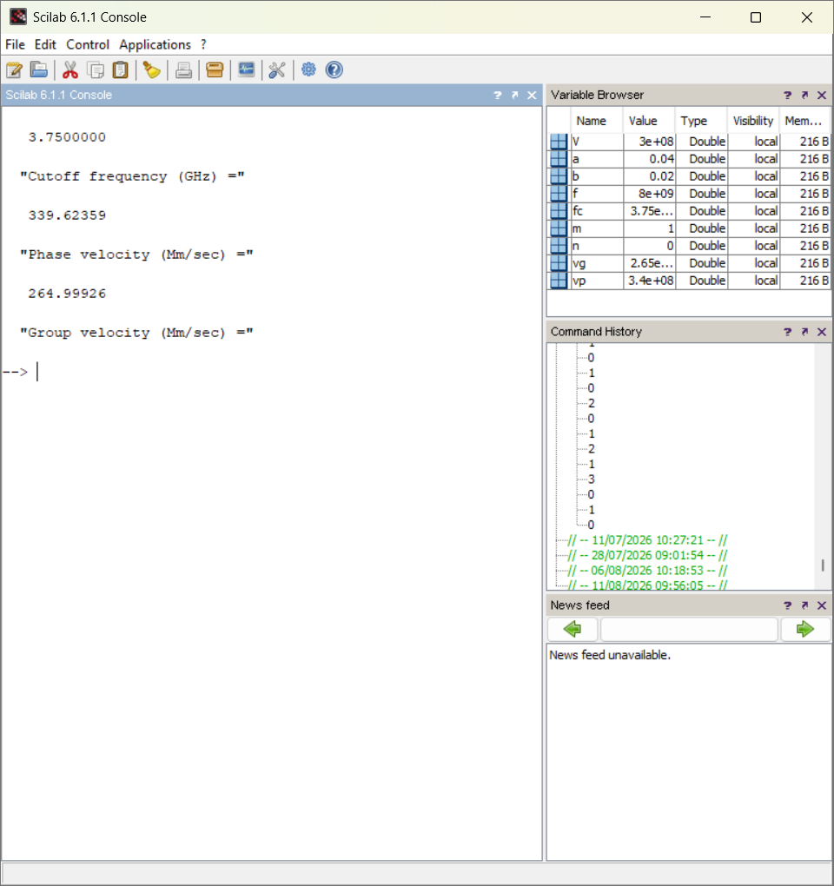
Result:
As the waveguide width a is reduced, the cutoff frequency fc increases (since fc ∝ 1/a). Because the operating frequency stays close to the rising cutoff frequency, the phase velocity vp increases sharply while the group velocity vg decreases, showing stronger dispersion as the width approaches the cutoff condition. Reducing a from 4.0 cm to 2.0 cm nearly doubles the cutoff frequency and more than doubles vp while more than halving vg.
Test Case 2
A radar system operates at f = 15 GHz with waveguide dimensions a = 2.5 cm and b = 1.25 cm. (1) Compute the cutoff frequency for the TE10 mode. (2) Determine the phase and group velocities for the TE10 mode. (3) Suggest strategies to maintain radar signal fidelity if dispersion is critical.
Code -
clc; clear; close;
V=3*10^8;
a=0.025; b=0.0125; f=15*10^9;
m=1; n=0;
fc=(V/2)*sqrt((m/a)^2+(n/b)^2);
disp(fc*10^-9,'Cutoff frequency (GHz) =');
vp=V/sqrt(1-(fc/f)^2);
disp(vp*10^-6,'Phase velocity (Mm/sec) =');
vg=V*V/vp;
disp(vg*10^-6,'Group velocity (Mm/sec) =');
Output:
a = 2.5 cm, b = 1.25 cm, f = 15 GHz, mode TE10
Parameter | Simulation Result | Theoretical Result
Cutoff frequency fc (GHz) | 6.000 | 6.000
Phase velocity vp (Mm/s) | 327.33 | 327.33
Group velocity vg (Mm/s) | 274.95 | 274.95
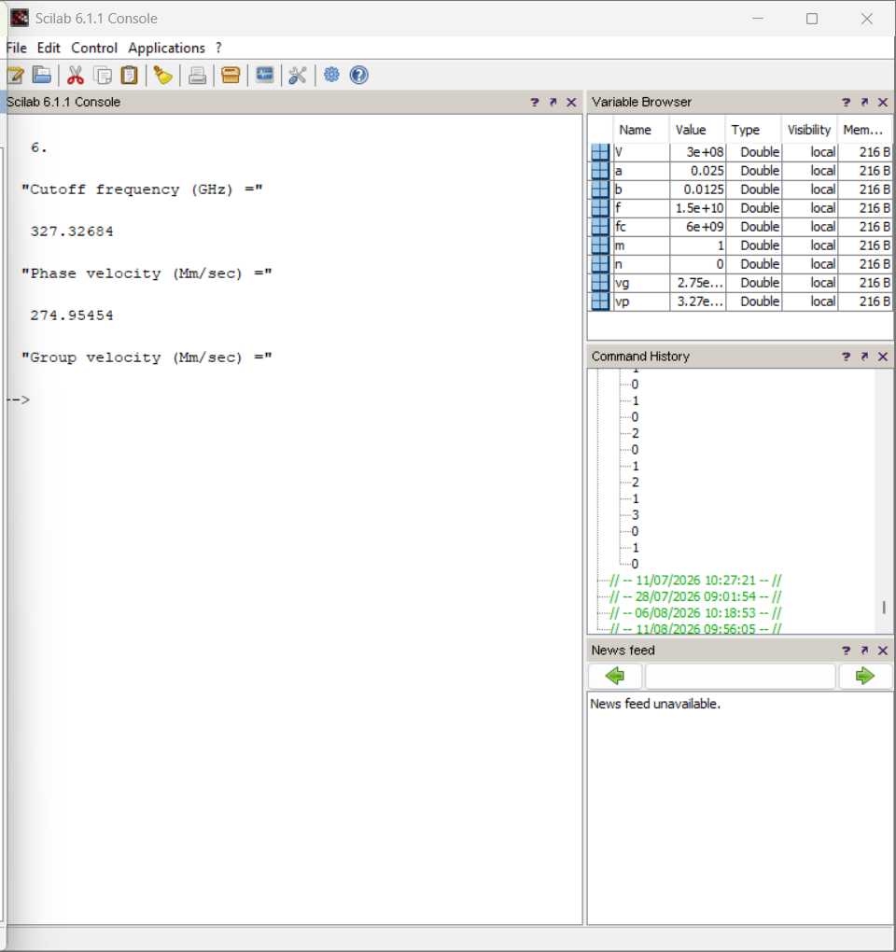
Result:
For the radar waveguide (a = 2.5 cm, b = 1.25 cm) operating at 15 GHz, the TE10 cutoff frequency is 6 GHz, well below the operating frequency, giving a moderate dispersion (vp = 327.33 Mm/s, vg = 274.95 Mm/s, both close to c). To preserve signal fidelity where dispersion is critical, the operating frequency should be kept well above cutoff (f >> fc), a single dominant mode (TE10) should be maintained by suitable waveguide sizing, and dispersion-compensation or narrowband filtering can be used to minimise pulse spreading.
Test Case 3
A waveguide with a = 5.0 cm and b = 2.5 cm carries a signal at f = 10 GHz. (1) Determine the number of TE modes that can propagate. (2) For the TE10 mode, calculate the phase and group velocities. (3) Discuss the effect of multiple propagating modes on transmission quality.
Code -
clc; clear; close;
V=3*10^8;
a=0.05; b=0.025; f=10*10^9;
modes=[1 0;0 1;1 1;2 0;2 1;0 2];
for i=1:6
m=modes(i,1); n=modes(i,2);
fc=(V/2)*sqrt((m/a)^2+(n/b)^2);
printf('TE%d%d fc=%f GHz Propagate=%d\n',m,n,fc*10^-9,fc<f);
end
Output:
Mode (m,n) | Cutoff Frequency fc (GHz) - Sim | Propagation (Y/N) - Sim | fc (GHz) - Theory | Propagation (Y/N) - Theory
TE10 | 3.000 | Yes | 3.000 | Yes
TE01 | 6.000 | Yes | 6.000 | Yes
TE11 | 6.708 | Yes | 6.708 | Yes
TE20 | 6.000 | Yes | 6.000 | Yes
TE21 | 8.485 | Yes | 8.485 | Yes
TE02 | 12.000 | No | 12.000 | No
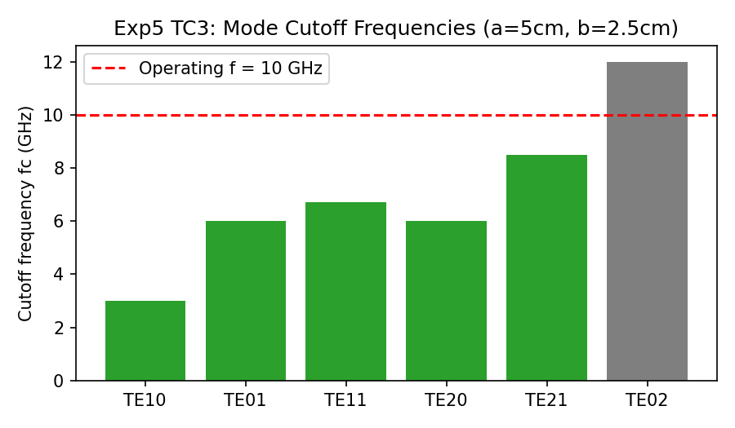
Result: Five TE modes can propagate at 10 GHz — TE10, TE01, TE11, TE20, TE21 (TE02 is cut off).
TE10 mode output (a = 5.0 cm, b = 2.5 cm, f = 10 GHz):
Parameter | Simulation Result | Theoretical Result
Cutoff frequency fc (GHz) | 3.000 | 3.000
Phase velocity vp (Mm/s) | 314.49 | 314.49
Group velocity vg (Mm/s) | 286.18 | 286.18
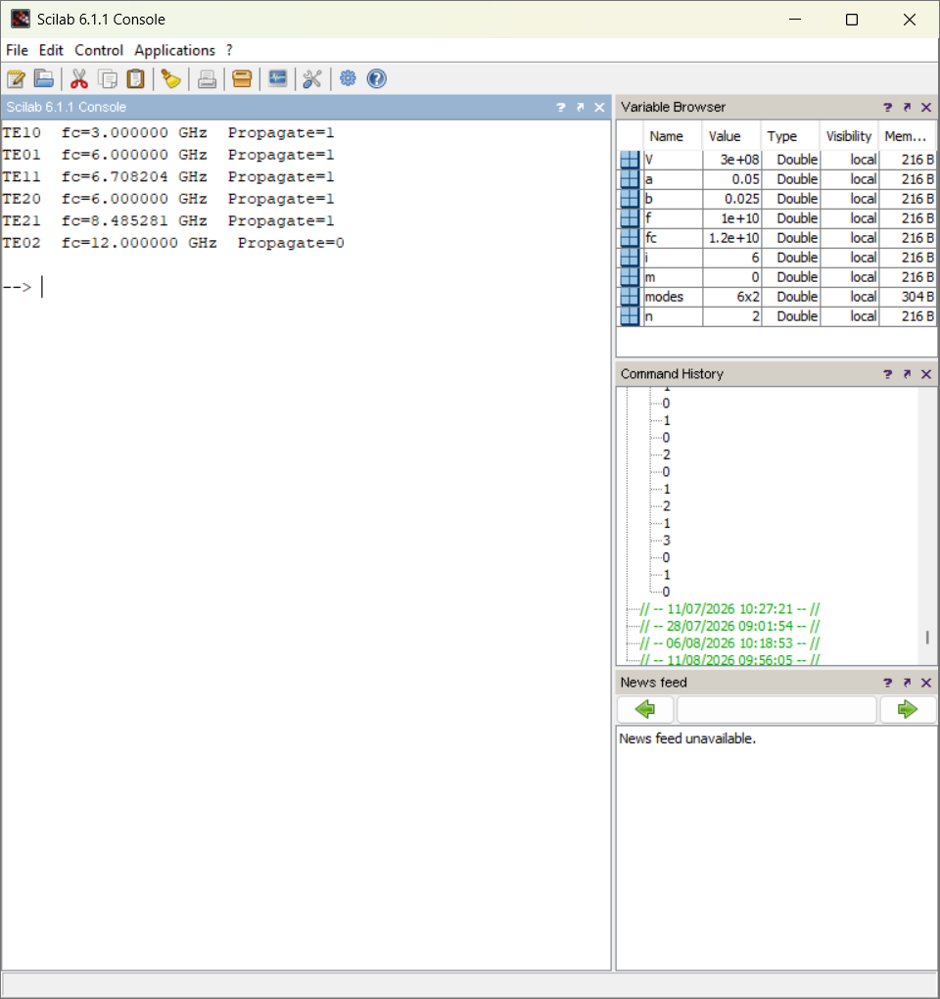
Result:
Five TE modes (TE10, TE01, TE11, TE20, TE21) can propagate in the waveguide (a = 5.0 cm, b = 2.5 cm) at 10 GHz, while TE02 is cut off. The presence of several simultaneously propagating modes causes each mode to travel with a different group velocity, leading to modal dispersion, signal distortion and inter-mode interference. This can be mitigated in practice by choosing waveguide dimensions such that only the dominant TE10 mode propagates (single-mode operation), using mode filters, or operating well below the cutoff frequency of the next higher-order mode.
Test Case 4
A research lab experiments with high-order TE modes (m, n > 1) in a waveguide with a = 3.0 cm, b = 1.5 cm and f = 12 GHz. (1) Calculate the cutoff frequency for the TE10 mode. (2) Compute the phase and group velocities of this mode. (3) Discuss how high-order modes can be used for mode multiplexing.
Code -
clc; clear; close;
V=3*10^8;
a=0.03; b=0.015; f=12*10^9;
modes=[1 0;2 0;0 1;1 1;2 1;3 0];
for i=1:6
m=modes(i,1); n=modes(i,2);
fc=(V/2)*sqrt((m/a)^2+(n/b)^2);
printf('TE%d%d fc=%f GHz Propagate=%d\n',m,n,fc*10^-9,fc<f);
end
// TE10 velocities
m=1; n=0;
fc10=(V/2)*sqrt((m/a)^2+(n/b)^2);
vp=V/sqrt(1-(fc10/f)^2); vg=V*V/vp;
disp(vp*10^-6,'Phase velocity (Mm/sec) ='); disp(vg*10^-6,'Group velocity (Mm/sec) =');
Output:
Mode (m,n) | Cutoff Frequency fc (GHz) - Sim | Propagation (Y/N) - Sim | fc (GHz) - Theory | Propagation (Y/N) - Theory
TE10 | 5.000 | Yes | 5.000 | Yes
TE20 | 10.000 | Yes | 10.000 | Yes
TE01 | 10.000 | Yes | 10.000 | Yes
TE11 | 11.180 | Yes | 11.180 | Yes
TE21 | 14.142 | No | 14.142 | No
TE30 | 15.000 | No | 15.000 | No
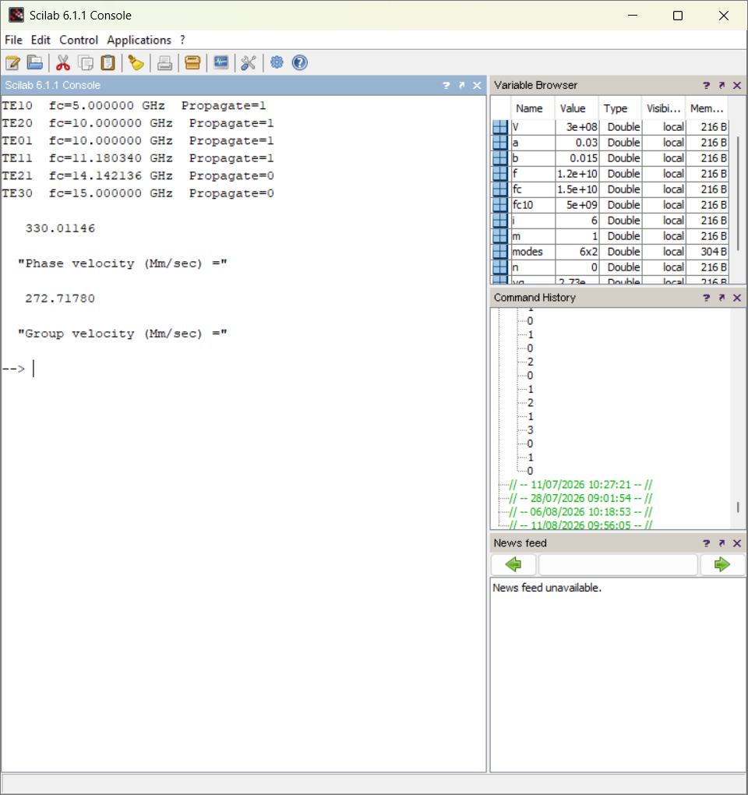
TE10 mode output (a = 3.0 cm, b = 1.5 cm, f = 12 GHz):
Parameter | Simulation Result | Theoretical Result
Cutoff frequency fc (GHz) | 5.000 | 5.000
Phase velocity vp (Mm/s) | 330.01 | 330.01
Group velocity vg (Mm/s) | 272.72 | 272.72
Result:
At f = 12 GHz, four modes (TE10, TE20, TE01, TE11) can propagate in the waveguide (a = 3.0 cm, b = 1.5 cm), while TE21 and TE30 are cut off. The dominant TE10 mode has vp = 330.01 Mm/s and vg = 272.72 Mm/s. Because several higher-order modes propagate simultaneously in this waveguide, they can, in principle, be exploited for mode-division multiplexing in advanced communication systems — using orthogonal field patterns of different modes to carry independent data channels within the same waveguide, provided mode-selective launching and detection are used to minimise cross-mode coupling.

